CS 255 System Design Document Template

This template lays out all the different sections that you need to complete for Project Two. Each section has guidance to prompt your thinking. You will need to continually reference the interview transcript as you work to make sure that you are addressing your client’s needs. There is no required length for the final document. Instead the goal is to complete each section based on what your client’s needs are. Remove this note when you are finished, and replace all bracketed text with the relevant information.

UML Diagrams

UML Use Case Diagram
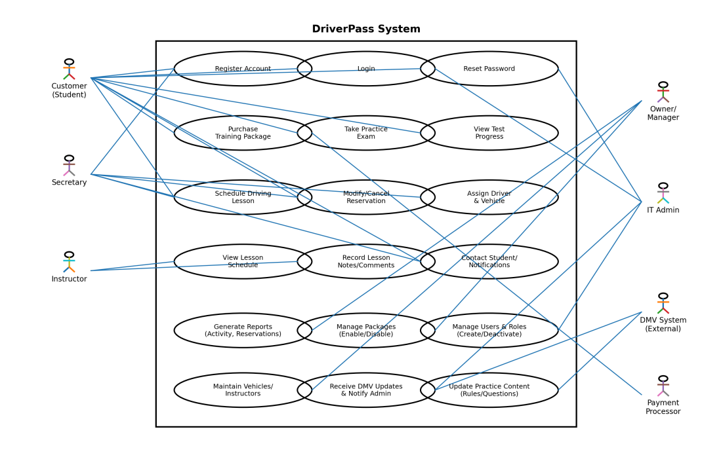

UML Activity Diagrams
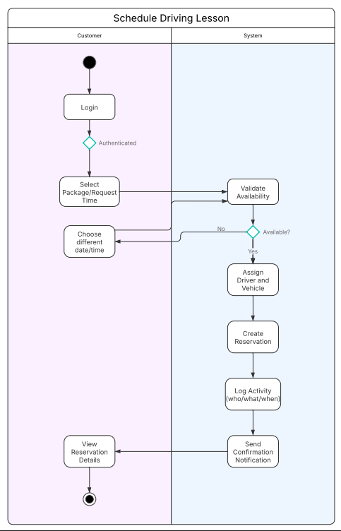
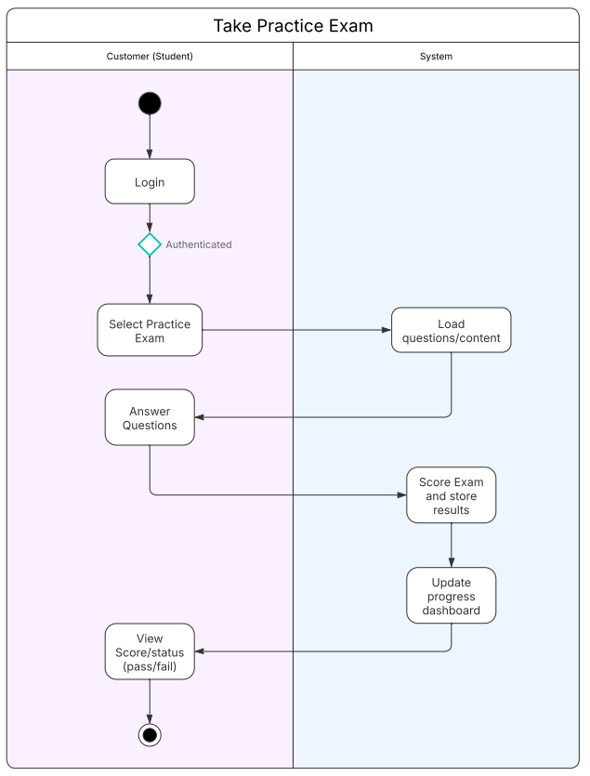

UML Sequence Diagram
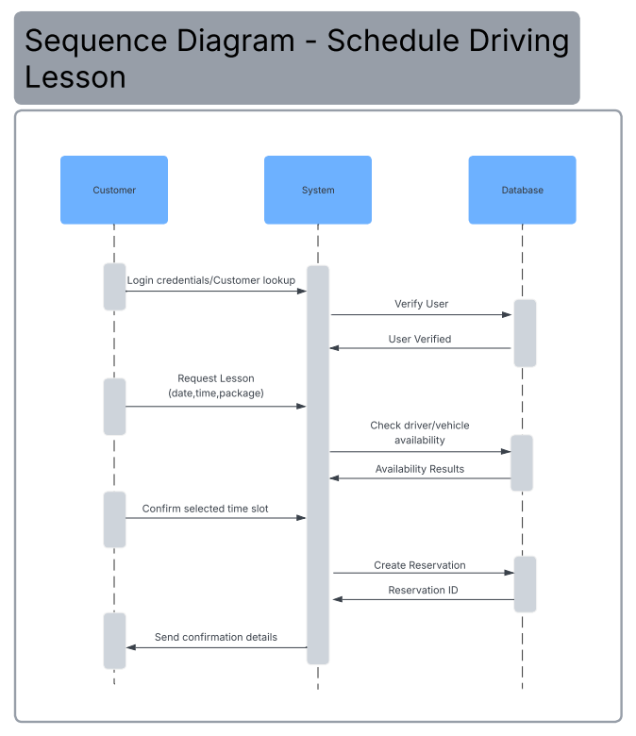

UML Class Diagram
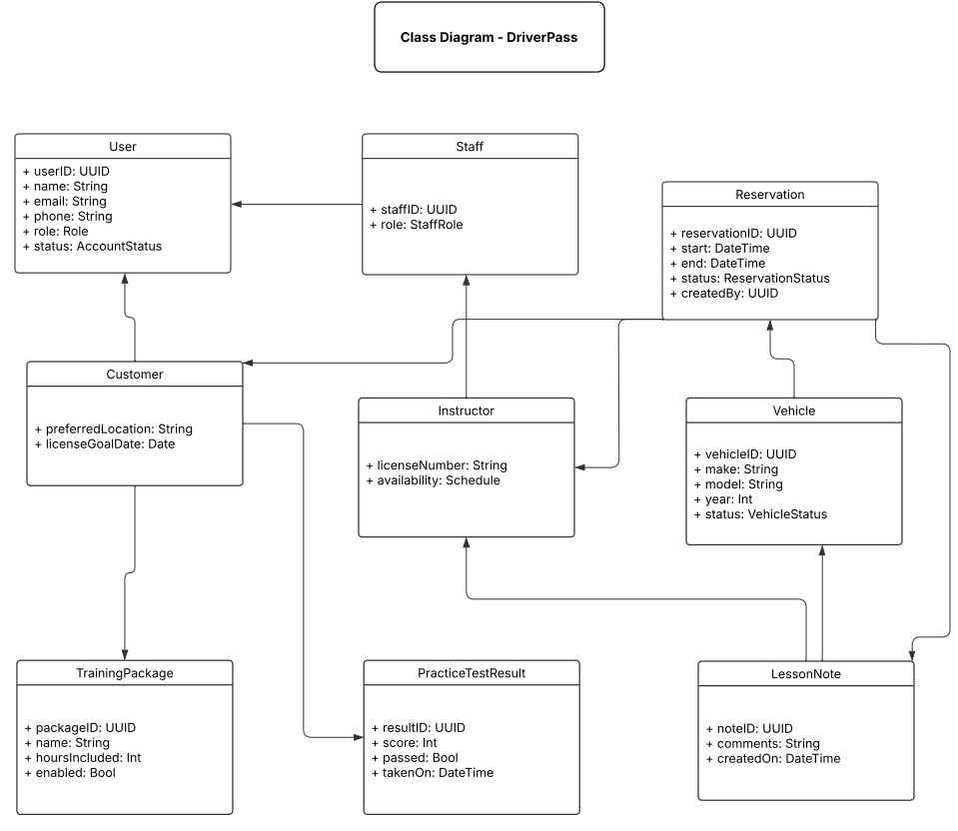

Technical Requirements

The DriverPass system requires both client-side and server-side resources to support its users and operations. Customers, instructors, and staff must be able to access the system using a modern web browser on a desktop or mobile device with a reliable internet connection. The server should be hosted in a cloud-based, Linux environment that supports scalability and high availability. A relational database is required to store user accounts, training packages, reservations, vehicles, lesson notes, practice test results, and audit logs, along with secure storage for backups and system data.

From a software and infrastructure standpoint, the system should use a web application framework that supports a client–server architecture and RESTful APIs to enable access across multiple platforms. Development and maintenance require UML modeling tools, version control, automated testing, and deployment pipelines. The infrastructure must include load balancing, encrypted network communication, role-based access control, monitoring, and regular backups to ensure performance, reliability, and security while protecting user information across all supported platforms.

